***The Department of Internal Medicine***

[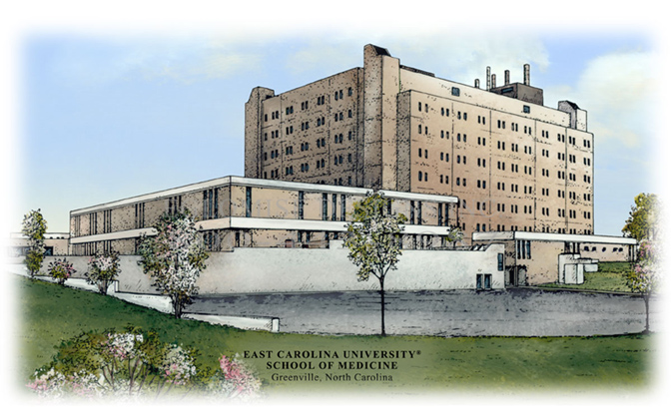](http://www.eglomisedesigns.com/index.php/categories/east-carolina-university-school-of-medicine-greenville-north-carolina)***The Brody School of Medicine***

***East Carolina University***

**29th Annual**

**Yash P. Kataria**

**Research Day - 2015**

**REGISTRATION FORM**

**VENDOR EXHIBITOR FEE $500.00**

VENDOR NAME_________________ VENDOR REPRESENTATIVE____________________

STREET/PO BOX_______________________________

CITY__________________________________________STATE___________ZIP CODE________________

PHONE________________________________________

EMAIL_________________________________________

METHOD OF PAYMENT/$500.00: VISA____________________MASTERCARD______________________

PLEASE PRINT NAME_________________________SIGNATURE__________________________________

BILLING ADDRESS (UNLESS SAME AS ABOVE)

STREET/PO BOX___________________________________CITY__________________________________

STATE________________ZIP CODE____________________

ACCOUNT #_________________________________________EXPIRATION_________________________

***FOR PROGRAM INFORMATION PLEASE CONTACT: PLEASE EMAIL REGISTRATION FORM TO:***

***CATHY MUNSON MY ATTENTION:***

***252-744-2533 CATHY MUNSON*** [***MUNSONC@ECU.EDU***](mailto:MUNSONC@ECU.EDU) ***MUNSONC@ECU.EDU***